Phillips Elementary 2018-2019 Arrival and Dismissal Procedures
Current Phillips parents, our arrival and dismissal procedures remain the same as last year. This sheet provides reminders about carpool procedures for everyone. Your cooperation and patience can help provide a safe and positive beginning and end to each school day for our students, staff, and families.
For drop off and pick up everyone enters through High Plains at the back of the school. It is imperative that parents remain in their vehicles and follow the traffic patterns during arrival and dismissal. Please stay alert and follow the directions of the traffic directors. You must stay off of your cell phone.
Arrival:
- ​For car drop off, parents should stay to the right of the carpool lane and follow around the backside of the building to the west side and drop off students by the gym.
- Students should exit cars only at the curb, for their safety.
- Parents must remain in vehicles.
- Students should open their own car doors and exit cars independently. If a student needs help, someone can assist him or her if needed.
- Walkers should follow the guidance of crossing guards
- Biker-riders will walk bikes while crossing the street/carpool lane and while on campus
- The front of the building is a drop-off zone for our special needs students, buses, and day care buses only. If you pull in the front of the school to drop off your student, you will be required to go back to the appropriate carpool zone in the back of the building to drop off your student.
- Use of cell phones by drivers is strictly prohibited in the school zone. The most important reason to stay off of your cell phone is student safety. You may be risking someone else’s and your own life to talk or text on your phone in a school zone. Driving parents have been ticketed for using their cell phones in our school zone.

Dismissal: Students will dismiss at 2:55. Please see the dismissal carpool map on page 2 of this document.

Carpool

- Please make sure your student name card is clearly visible in the window. Please do not put it flat on the dashboard, as it is difficult for us to see when it is there. The best place to put it is either to hang it on your rear view mirror (we have seen parents use a hanger to do this, great idea!), or put it on the visor so that it is visible when you flip the visor down. This sign MUST be displayed in order to make sure carpool goes quickly and smoothly. If you need another sign, PLEASE let your child’s teacher know so he/she can get you a new one.
- For pick up, 4-5 grade parents come in through the south side of the lane, enter the short loop and will move around to the west side (to the left) to pick up their student by the gym/playground.
- K-3 grade parents will enter through the south side and stay to the right to travel the large loop along the back side of the building. This means when entering on High Plains, you will go to the right.
- K-1 grade parents will stay in the right lanes. It is preferable for K-1 parents to remain in the right two lanes, while 2-3 grade parents may use the far left lane to pass the Kinder/1st grade stop, then get over to the right lanes once they are at the 2-3 stop (right past the big library windows.)
- Students are loaded into cars in the two right lanes for ALL grades. We do not load students into cars in the far left lane.
- After your student is picked up use the far left lane to exit the parking lot.

Walkers
- Walkers supervised by parents will walk with teachers to the field adjacent to the playground. Teachers will release students when they see parents.
- Independent walkers will walk to the field with teachers and be released to walk home.
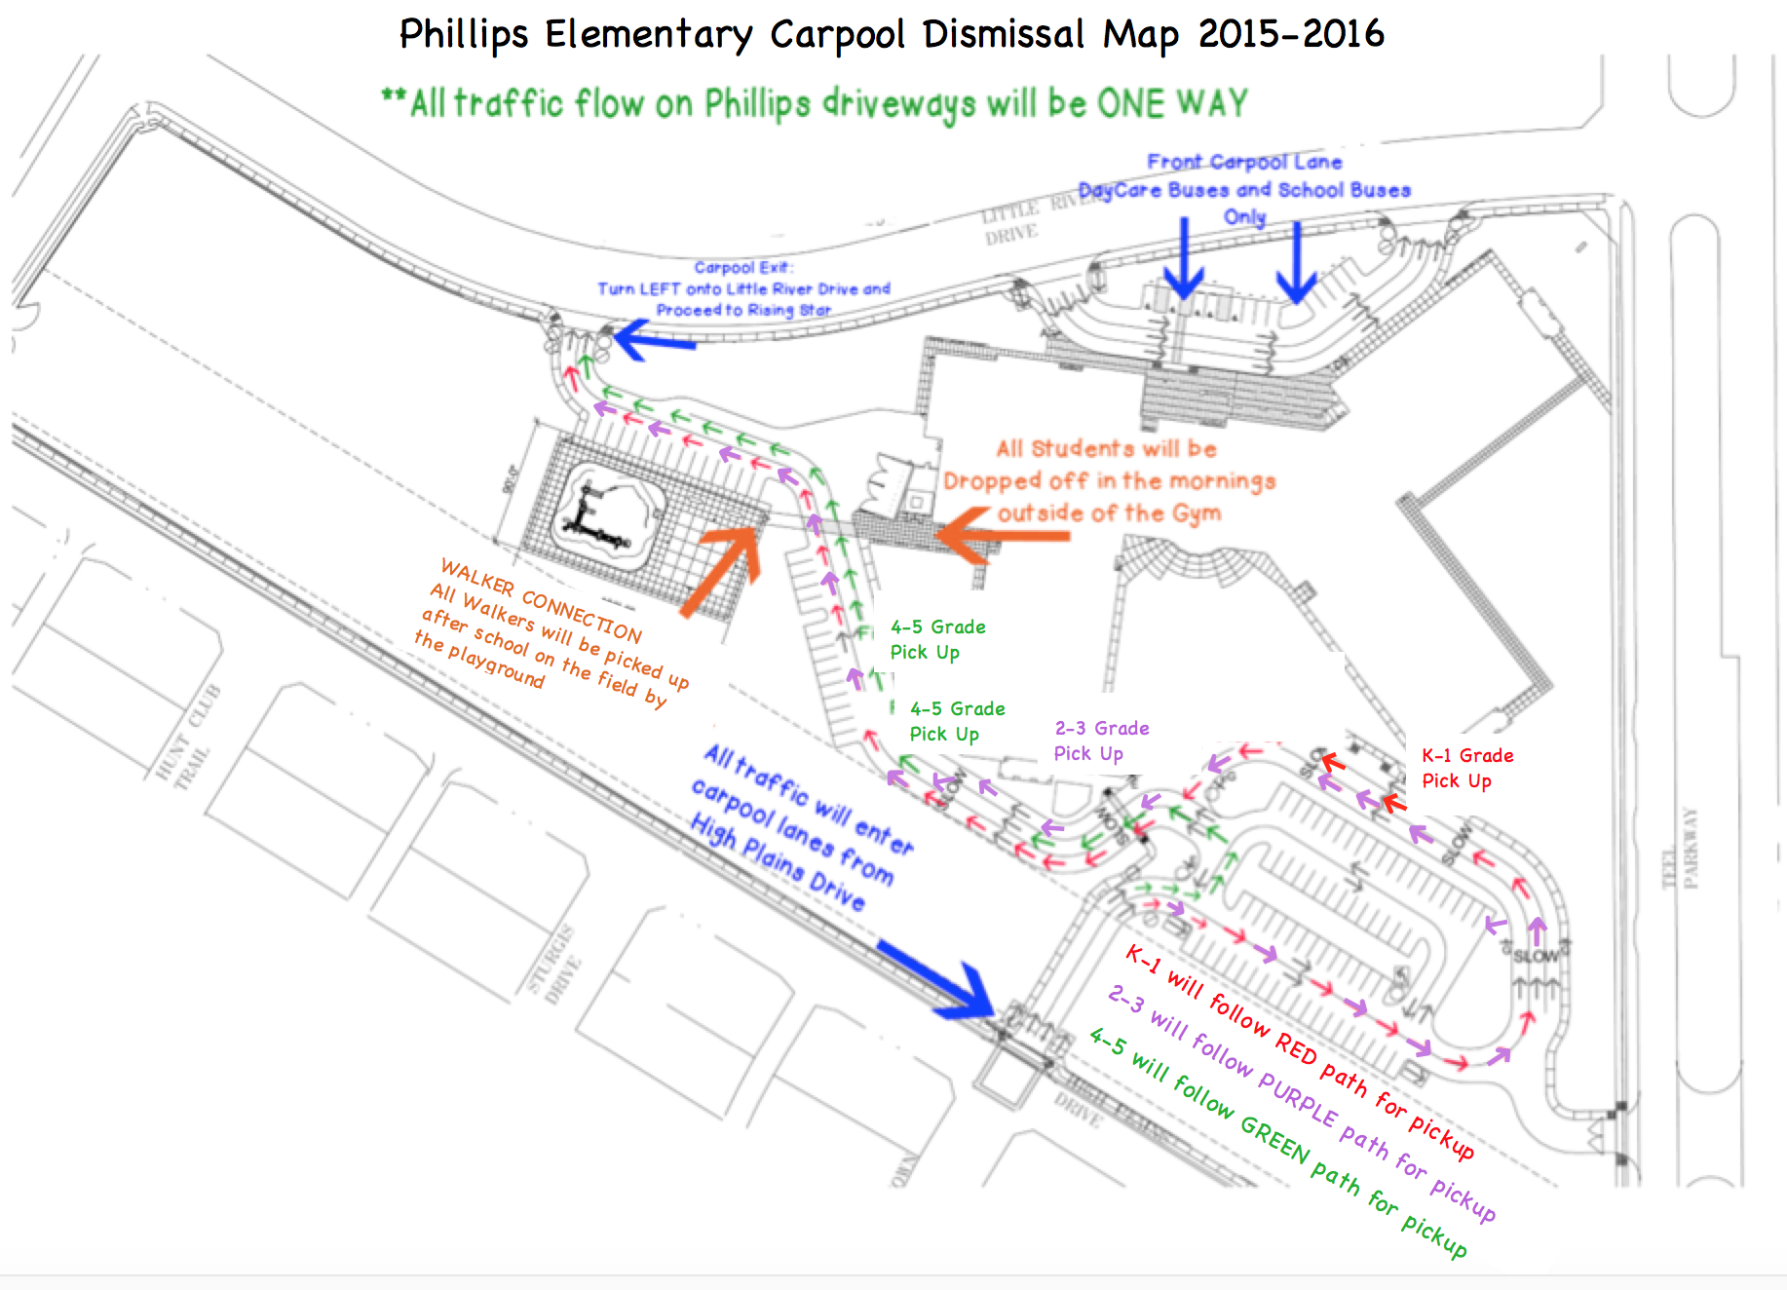
2016-2017

